Fundamentals Brushless DC Motor Review

The purpose of this document is to provide a comprehensive study and description of Brushless Direct Current (BLDC) Motors, their mechanical and technical aspects, compared with similar, but different types of motors, especially conventional DC motors and permanent Magnet Synchronous Motor (PMSM).

The diagram below provides an overview of every section and subsection that will be study and reviewed in this document: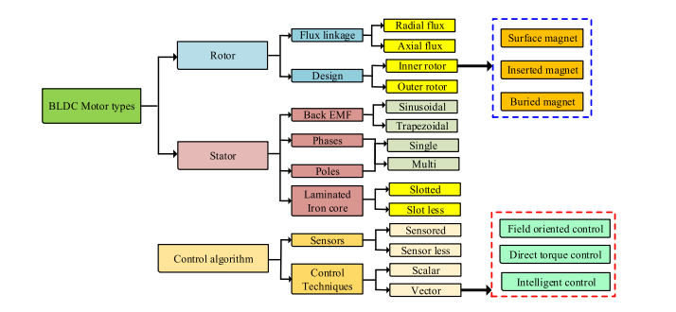

In addition to the mechanical and technical fundamentals of the motor, this document will also review various control algorithms that can be employed to operate BLDC motors effectively. These algorithms play a crucial role in optimizing the performance and efficiency of these motors.

**Bibliography used in this document:**

[1] - [Brushless DC Motor Fundamentals Application Note](https://www.monolithicpower.com/media/document/Brushless_DC_Motor_Fundamentals.pdf):

* This document provides a general overview of BLDC motors, their advantages against other commonly-used motors, structure, electromagnetic principles, and mode of operation.
* The document also provides detailed descriptions of motor structure, working principle, characteristics and control methods.
* It also examines control principles using Hall sensors for both single-phase and three-phase BLDC motors, and introduces sensorless control methods using BEMF for a three-phase BLDC motor.

[2] - [A Review of BLDC Motor: State of Art, Advanced Control Techniques, and Applications](https://ieeexplore.ieee.org/abstract/document/9774372/)

* This paper provides a comprehensive study on various advanced controls of BLDC motors such as fault tolerance control, Electromagnetic interference reduction, field orientation control (FOC), direct torque control (DTC), current shaping, input voltage control, intelligent control, drive-inverter topology, and its principle of operation in reducing torque ripples.
* It also discusses BLDC motor history, types of BLDC motor, BLDC motor structure, Mathematical modeling of BLDC and BLDC motor standards for various applications.

[3] - [Brushless DC (BLDC) Motor Fundamentals](https://ww1.microchip.com/downloads/en/AppNotes/00885a.pdf)

* This document provides a general overview of BLDC motors, construction and operating principles.
* It also makes a detailed comparison with other types of motors (BLDC vs Brushed DC Motor vs Induction Motors).
* It also explains typical BLDC motor applications and what a typical motor technical specification looks like.

[4] - [Brushless DC Motor: Construction and Applications](https://theijes.com/papers/v2-i5/Part.3/K0253072077.pdf)

* **Construction and Working Principle:** The document discusses the construction and working principle of BLDC motors. It explains how the functions of commutators and brushes are implemented by solid-state switches, resulting in maintenance-free motors known as brushless dc motors.
* **Comparison with Other Motors:** The document compares the Brushless DC Motor with conventional DC motors and AC Induction motors1. It highlights the advantages of BLDC motors over these other types of motors.
* **Applications**: The document discusses various applications of the Brushless DC Motor.

[5] - [Brushless DC motor control without position and speed sensors](https://ieeexplore.ieee.org/abstract/document/120220)

* This document presents a new control strategy for a brushless DC motor without position and speed sensors.
* The control is performed by software using the DSP-TMS320C25. The prototype has been constructed using a 1.5 kW, 154 V, 2000 r/min, four-pole motor.

[6] - [Performance analysis and comparison of BLDC motor drive using PI and FOC](https://ieeexplore.ieee.org/abstract/document/7955350/)

* The paper builds a simple, accurate, and fast-running model of a BLDC motor drive in MATLAB/Simulink1.
* **Modelling, simulation, and analysis of PI controller and field-oriented controller (FOC)** based **sensorless** scheme for a BLDC motor has been carried out in this study.

[7] - [Position and Speed Control of Brushless DC Motors Using Sensorless Techniques and Application Trends](https://www.mdpi.com/1424-8220/10/7/6901)

* This paper provides a technical review of position and speed sensorless methods for controlling Brushless Direct Current (BLDC) motor drives.
* The study includes a **deep overview of state-of-the-art back-EMF sensing methods**.
* Techniques based on estimation and models are briefly analyzed, such as Sliding-mode Observer, Extended Kalman Filter, Model Reference Adaptive System, Adaptive observers (Full-order and Pseudoreduced-order) and Artificial Neural Networks.

[8] - [Control BLDC Motor Speed using PID Controller](https://www.researchgate.net/profile/Md-Mahmud-53/publication/340427917_Control_BLDC_Motor_Speed_using_PID_Controller/links/5e8b313da6fdcca789f84e8b/Control-BLDC-Motor-Speed-using-PID-Controller.pdf):

* This paper describes the design of the BLDC motor control system using MATLAB/SIMULINK software for Proportional Integral Derivative (PID) algorithm that can more effectively improve the speed control of these types of motors.
* It provides an overview of the functionality and design of the PID controller.

[9] – [“Técnicas adaptativas de controle aplicadas a um motor BLDC baseadas em lógica fuzzy e sua otimização por enxame de partículas”](https://repositorio.utfpr.edu.br/jspui/handle/1/26030)

* **Objective**: compare different control techniques, such as PID, Hybrid Fuzzy-PID and Hybrid Fuzzy-PID optimized by PSO for speed control of a BLDC motor
* **Simulations and Implementation**: carried out in Simulink software and its practical implementation in an ESP32 microcontroller.

[10] - [The Brushless DC motor control system Based on neural network fuzzy PID control of power electronics technology](https://www.sciencedirect.com/science/article/pii/S0030402622011421)

* The document discusses the development and control of Brushless Direct Current (BLDC) motors. It emphasizes the role of power electronics technology in the rapid development of these motors. The paper also explores the **use of a neural network fuzzy PID control method to study the control system of the BLDC motor**.
* Furthermore, the document analyzes and designs the application of model prediction in BLDC current loop control.
* **Simulation**: model of the brushless DC motor control system is built in MATLAB to validate this control system. The simulation results indicate that the brushless DC motor control system based on neural network fuzzy PID control can effectively improve the control effect.

1. INTRODUCTION (comparação com outros motores*, a faltar)

The BLDC motor is electrically commutated by power switches instead of brushes. Compared with a brushed DC motor or an induction motor, the BLDC motor has many advantages:

* Higher efficiency and reliability
* Lower acoustic noise
* Smaller and lighter (the ratio of torque delivered to the size of the motor is higher, making it useful in applications where space and weight are critical factors)
* Greater dynamic response
* Better speed versus torque characteristics
* Higher speed range
* Longer life (Long operating life)

As the name implies, BLDC motors do not use brushes for commutation; instead, they are electronically commutated. BLDC motors have many advantages over brushed DC motors and induction motors.

1. CONSTRUCTION AND OPERATING PRINCIPLE

BLDC motors are a type of synchronous motor. This means the magnetic field generated by the stator and the magnetic field generated by the rotor rotate at the same frequency. BLDC motors do not experience the “slip” that is normally seen in induction motors.

BLDC motor physical design is divided into two parts: stator and rotor.

* 1. STATOR

The stator in BLDC can be classified based on the number of phases, laminated core types, and back EMF.

* + 1. Number of phases

BLDC motors come in single-phase, 2-phase and 3-phase configurations. **Corresponding to its type, the stator has the same number of windings** (“enrolamentos”). Out of these, 3-phase motors are the most popular and widely used.

A single-phase motor has one stator winding—wound either clockwise or counter-clockwise along each arm of the stator—to produce four magnetic poles as shown in (a).

By comparison, a 3-phase motor has three windings as shown in (b). Each phase turns on sequentially to make the rotor revolve.

The stator coil winding is star or delta connected. These winding models are preferred depending upon the application. Star connection is preferred for high torque low-speed applications and delta connection is preferred for low torque low-speed applications.

* + 1. Laminated Iron Cores

The laminated iron cores are classified as slotted and slot-less cores. Due to the reaction of the PM flux with the stator’s varying permeance, the slotted stator often generates high-order spatial harmonics. This causes a small vibrating torque on the shaft, which is referred to as cogging torque. As a result, it reduces operational noise preferred for slot-less machines. Furthermore, slot-less machines have lower rotational eddy loss, allowing the motor to run at faster speeds.

* + 1. Back EMF

There are **two types of stator windings**: trapezoidal and sinusoidal, which refers to the shape of the back electromotive force (BEMF) signal. The shape of the BEMF is determined by different coil interconnections and the distance of the air gap. In addition to the BEMF, the phase current also follows a trapezoidal and sinusoidal shape. A sinusoidal motor produces smoother electromagnetic torque than a trapezoidal motor, though at a higher cost due to their use of extra copper windings. (However, this comes with an extra cost, as the sinusoidal motors take extra winding interconnections because of the coils distribution on the stator periphery, thereby increasing the copper intake by the stator windings) **A BLDC motor uses a simplified structure with trapezoidal stator windings.**

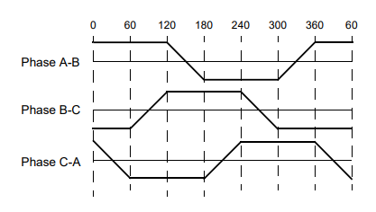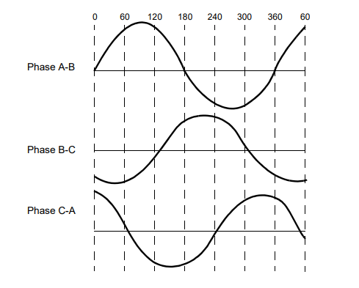



When a BLDC motor rotates, each winding generates a voltage known as back Electromotive Force or back EMF, which opposes the main voltage supplied to the windings according to Lenz’s Law. The polarity of this back EMF is in the opposite direction of the energized voltage. Back EMF depends mainly on three factors:

* Angular velocity of the rotor.
* Magnetic field generated by rotor magnets.
* The number of turns in the stator windings.

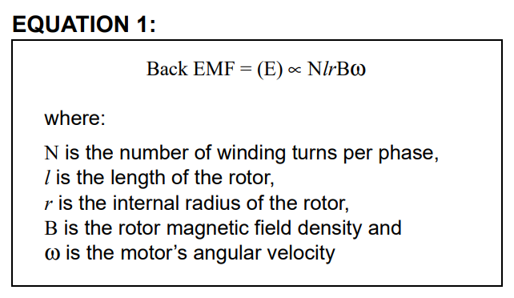

In the context of a Brushless DC (BLDC) motor, when the motor rotates, each winding generates this Back EMF. It’s important to note that the magnitude of the Back EMF is directly proportional to the speed of the motor (Once the motor is designed, the rotor magnetic field and the number of turns in the stator windings remain constant. The only factor that governs back EMF is the angular velocity or speed of the rotor and as the speed increases, back EMF also increases). This means that as the speed of the motor increases, so does the Back EMF.

**This relationship can be used to infer the speed of the motor by measuring the Back EMF.** The motor technical specification gives a parameter called, back EMF constant (Ke) that can be used to estimate back EMF for a given speed.

**In essence, Back EMF is a fundamental aspect of how motors work and is crucial in controlling and maintaining their operation.**

**“(Explicação do chat bing)**A tensão de retorno, ou força eletromotriz de retorno (back EMF), é gerada nas bobinas de um motor BLDC quando ele está em rotação. [Esta tensão é uma consequência direta da Lei de Faraday da indução eletromagnética, que afirma que uma mudança no campo magnético dentro de um circuito fechado induzirá uma tensão (ou EMF) nesse circuito1](https://electronics.stackexchange.com/questions/600776/inductor-back-emf-direction-relative-to-changing-current).

[A Lei de Lenz, por outro lado, afirma que a direção da corrente induzida será tal que ela se oporá à mudança que a causou2](https://physics.stackexchange.com/questions/308979/how-does-current-flow-if-back-emf-equals-to-applied-voltage). No caso de um motor BLDC em rotação, a mudança é o campo magnético rotativo. Portanto, a corrente induzida (e a tensão de retorno correspondente) será em uma direção que se opõe a essa mudança. [Isso resulta na tensão de retorno tendo uma polaridade oposta à tensão aplicada1](https://electronics.stackexchange.com/questions/600776/inductor-back-emf-direction-relative-to-changing-current)[3](https://physics.stackexchange.com/questions/184541/if-induced-voltage-back-emf-is-equal-and-opposite-to-applied-voltage-what-dri).

A tensão aplicada é a tensão que você fornece ao motor para fazê-lo funcionar. É essa tensão que causa a corrente através das bobinas do motor, criando um campo magnético que faz o motor girar.

A tensão de retorno, por outro lado, é a tensão que o próprio motor gera quando está em rotação. [Esta tensão é realmente um subproduto da operação do motor - à medida que o motor gira, seu campo magnético rotativo induz essa tensão nas bobinas do motor1](https://electronics.stackexchange.com/questions/600776/inductor-back-emf-direction-relative-to-changing-current)[3](https://physics.stackexchange.com/questions/184541/if-induced-voltage-back-emf-is-equal-and-opposite-to-applied-voltage-what-dri).

[Portanto, em resumo, a tensão aplicada e a tensão de retorno são opostas porque são o resultado da interação entre a corrente elétrica e o campo magnético dentro do motor, conforme descrito pelas leis de Faraday e Lenz1](https://electronics.stackexchange.com/questions/600776/inductor-back-emf-direction-relative-to-changing-current)[3](https://physics.stackexchange.com/questions/184541/if-induced-voltage-back-emf-is-equal-and-opposite-to-applied-voltage-what-dri)[2](https://physics.stackexchange.com/questions/308979/how-does-current-flow-if-back-emf-equals-to-applied-voltage).

**“**

* 1. Rotor

A rotor consists of **a shaft** (“eixo” que é a parte que gira no motor”) and **a hub** (“que é a parte central do rotor onde os ímãs permanentes são fixados”) **with permanent magnets arranged to form between two to eight pole pairs** that alternate between north and south poles.

The different types/configurations of a BLDC motor rotor can be defined by 2 different characteristics, **Design and Flux Linkage**

* + 1. Design

The motor design is constructed with various configurations such as inner rotor and outer rotor.

In the outer rotor-designed BLDC motor the rotor permanent magnet is embedded at the outer surface and stator windings are kept stationary inside. The outer rotor BLDC increases the output torque and power density of the motor. The outer rotor BLDC motor is mainly used in electric vehicles, drones, variable drive industries, water pumping, and home electronics.

In outer (external) rotor BLDC motor design, the airgap radius between stator and rotor is minimized. Thus, increasing the torque capability per unit length and current.

Inner rotor motor design also provides good power characteristics over dynamic conditions. Magnetic flux components are improvised by adjusting the mechanical constraints.

The comparison of the inner rotor and outer rotor BLDC is discussed in the following Table.

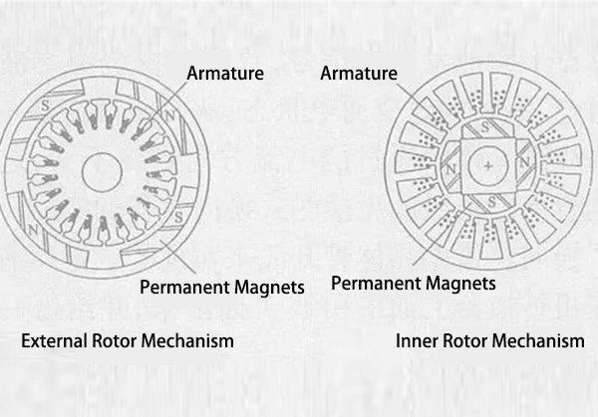

Next figure shows cross sections of different arrangements of magnets in a rotor.

* + 1. Flux Linkage

Depending on the expectation of the customers, BLDC motors drives are integrated in different ways such as magnetic field path radial and axial flux.

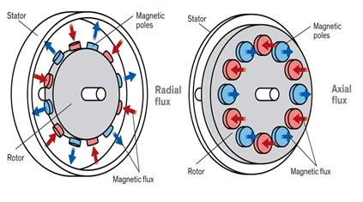

**What are the advantages of an axial flux motor?** [**[link, BLDC motors]**](https://www.goldenmotor.com/)

Axial flux motors have several advantages over traditional radial flux motors. Here are some of the advantages of axial flux motors:

* **High torque density:** Axial flux motors have a higher torque density than radial flux motors, which means they can deliver more torque per unit of volume. This makes them ideal for applications where space is at a premium, such as electric vehicles.
* **High efficiency:** Axial flux motors have a high efficiency, which means they can convert a higher percentage of electrical energy into mechanical energy. This results in lower energy losses and longer battery life in electric vehicles.
* **Compact size and low weight:** Axial flux motors are more compact and lightweight than radial flux motors of similar power output. This makes them suitable for applications where weight and size are critical, such as drones and robots.
* **Lower cogging torque:** Axial flux motors have a lower cogging torque than radial flux motors, which means they have less resistance to motion at low speeds. This makes them ideal for applications that require precise control, such as robotics and automation.
* **Higher power density**: Axial flux motors can handle a higher power density than radial flux motors, which means they can deliver more power per unit of weight or volume. This makes them ideal for applications that require high power output, such as electric vehicles and aircraft.
  + 1. Material Construction

Based on the required magnetic field density in the rotor, the proper magnetic material is chosen to make the rotor. Ferrite magnets are traditionally used to make permanent magnets. As the technology advances, rare earth alloy magnets are gaining popularity. The ferrite magnets are less expensive, but they have the disadvantage of low flux density for a given volume. In contrast, the alloy material has high magnetic density per volume and enables the rotor to compress further for the same torque. Also, these alloy magnets improve the size-to-weight ratio and give higher torque for the same size motor using ferrite magnets. Neodymium (Nd), Samarium Cobalt (SmCo) and the alloy of Neodymium, Ferrite and Boron (NdFeB) are some examples of rare earth alloy magnets.

* 1. Theory of Operation

Each commutation sequence has one of the **windings energized to positive power** (current that enters the winding), the **second winding is negative** (current exits the winding) and the **third is in a non-energized** condition. Torque is produced because of the interaction between the magnetic field generated by the stator coils and the permanent magnets.

Using the three-phase motor, the process starts when current flows through one of the three stator windings and generates **a magnetic pole that attracts the closest permanent magnet of the opposite pole.** The rotor will move if the current shifts to an adjacent winding. Sequentially charging each winding will cause the rotor to follow in a rotating field. **The torque in this example depends on the current amplitude and the number of turns on the stator windings, the strength and the size of the permanent magnets, the air gap between the rotor and the windings, and the length of the rotating arm.**

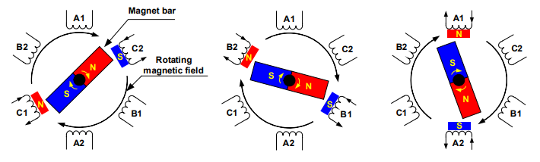

*Figure 4 - Motor Rotation*

Ideally, the peak torque occurs when these two fields are at 90° to each other and falls off as the fields move together. To keep the motor running, the magnetic field produced by the windings should shift position, as the rotor moves to catch up with the stator field. What is known as **“Six-Step Commutation” defines the sequence of energizing the windings**.

* + 1. Hall Sensors

Unlike a brushed DC motor, the commutation of a BLDC motor is controlled electronically. To rotate the BLDC motor, the stator windings should be energized in a sequence. It is important to know the rotor position in order to understand which winding will be energized following the energizing sequence. Rotor position is sensed using **Hall effect sensors** embedded into the stator. Most BLDC motors have three Hall sensors embedded into the stator on the non-driving end of the motor. Whenever the **rotor magnetic poles pass near the Hall sensors, they give a high or low signal, indicating the N or S pole is passing near the sensors.** Based on the combination of these three Hall sensor signals, the exact sequence of commutation can be determined.

**Note:** *Hall Effect Theory: If an electric current carrying conductor is kept in a magnetic field, the magnetic field exerts a transverse force on the moving charge carriers which tends to push them to one side of the conductor. This is most evident in a thin flat conductor. A buildup of charge at the sides of the conductors will balance this magnetic influence, producing a measurable voltage between the two sides of the conductor. The presence of this measurable transverse voltage is called the Hall effect after E. H. Hall who discovered it in 1879.*

Hall sensors are embedded into the stationary part of the motor. Embedding the Hall sensors into the stator is a complex process because any misalignment in these Hall sensors, with respect to the rotor magnets, will generate an error in determination of the rotor position. To simplify the process of mounting the Hall sensors onto the stator, some motors may have the Hall sensor magnets on the rotor, in addition to the main rotor magnets. These are a scaled down replica version of the rotor. Therefore, whenever the rotor rotates, the Hall sensor magnets give the same effect as the main magnets. The Hall sensors are normally mounted on a PCB and fixed to the enclosure cap on the non-driving end. This enables users to adjust the complete assembly of Hall sensors, to align with the rotor magnets, in order to achieve the best performance. Based on the physical position of the Hall sensors, there are two versions of output. The Hall sensors **may be at 60° or 120° phase shift to each other**. Based on this, the **motor manufacturer defines the commutation sequence, which should be followed when controlling the motor.**

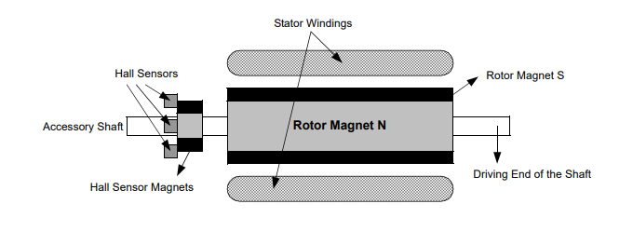

*Figure 5 - A transverse section of a BLDC motor with a rotor that has alternate N and S permanent magnets.*

* + 1. Switch Configuration and PWM

Brushless DC motors use electric switches to realize current commutation, and thus continuously rotate the motor. These electric switches are usually connected in an H-bridge structure for a single-phase BLDC motor, and a three-phase bridge structure for a three-phase BLDC motor shown in Figure 10. Usually the high-side switches are controlled using pulse-width modulation (PWM), **which converts a DC voltage into a modulated voltage**, which easily and efficiently limits the startup current, control speed and torque. Generally, raising the switching frequency increases PWM losses, though lowering the switching frequency limits the system’s bandwidth and can raise the ripple current pulses to the points where they become destructive or shut down the BLDC motor driver.

* + 1. Commutation Sequence

Figure 9 shows a block diagram of the controller used to control a BLDC motor. Q0 to Q5 are the power switches controlled by the PIC18FXX31 microcontroller. Based on the motor voltage and current ratings, these switches can be MOSFETs, or IGBTs, or simple bipolar transistors.

This is an example of Hall sensor signals having a 60-degree phase shift with respect to each other. As we have previously discussed in the “Hall Sensors” section, the Hall sensors may be at 60° or 120° phase shift to each other. **When deriving a controller for a particular motor, the sequence defined by the motor manufacturer should be followed**. Referring to Figure 9, if the signals marked by PWMx are switched ON or OFF according to the sequence, the motor will run at the rated speed. This is assuming that the DC bus voltage is equal to the motor rated voltage, plus any losses across the switches.

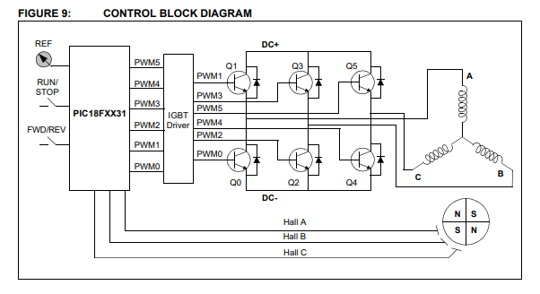

**Note about PWM signals about this example:**

To vary the speed, these signals should be Pulse Width Modulated (PWM) at a much higher frequency than the motor frequency. As a rule of thumb, the PWM frequency should be at least 10 times that of the maximum frequency of the motor. When the duty cycle of PWM is varied within the sequences, the average voltage supplied to the stator reduces, thus reducing the speed. Another advantage of having PWM is that, if the DC bus voltage is much higher than the motor rated voltage, the motor can be controlled by limiting the percentage of PWM duty cycle corresponding to that of the motor rated voltage. This adds flexibility to the controller to hook up motors with different rated voltages and match the average voltage output by the controller, to the motor rated voltage, by controlling the PWM duty cycle. There are different approaches of controls. If the PWM signals are limited in the microcontroller, the upper switches can be turned on for the entire time during the corresponding sequence and the corresponding lower switch can be controlled by the required duty cycle on PWM. The potentiometer, connected to the analog-to-digital converter channel in Figure 9, is for setting a speed reference. Based on this input voltage, the PWM duty cycle should be calculated.

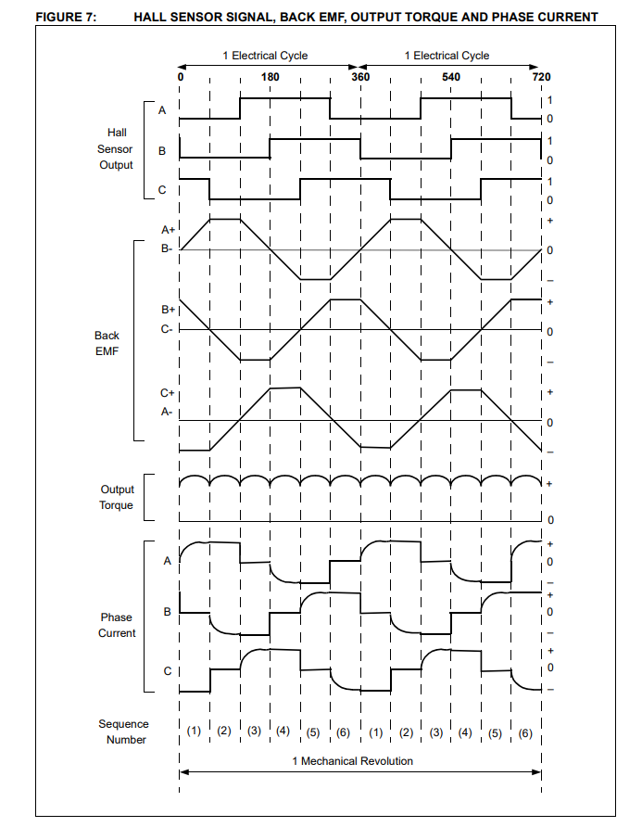

Figure 7 shows an example of Hall sensor signals with respect to back EMF and the phase current. Figure 8 shows the switching sequence that should be followed with respect to the Hall sensors. The sequence numbers on Figure 7 correspond to the numbers given in Figure 8. Every 60 electrical degrees of rotation, one of the Hall sensors changes the state. Given this, it takes six steps to complete an electrical cycle. In synchronous, with every 60 electrical degrees, the phase current switching should be updated. However, one electrical cycle may not correspond to a complete mechanical revolution of the rotor. The number of electrical cycles to be repeated to complete a mechanical rotation is determined by the rotor pole pairs. For each rotor pole pairs, one electrical cycle is completed. So, the number of electrical cycles/rotations equals the rotor pole pairs.

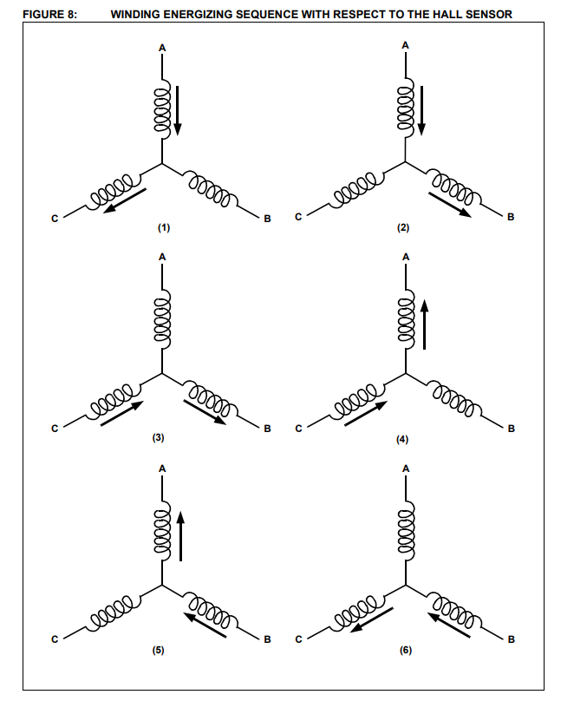

Table 3 and Table 4 show the sequence in which these power switches should be switched based on the Hall sensor inputs, A, B and C. Table 3 is for clockwise rotation of the motor and Table 4 is for counter clockwise motor rotation. 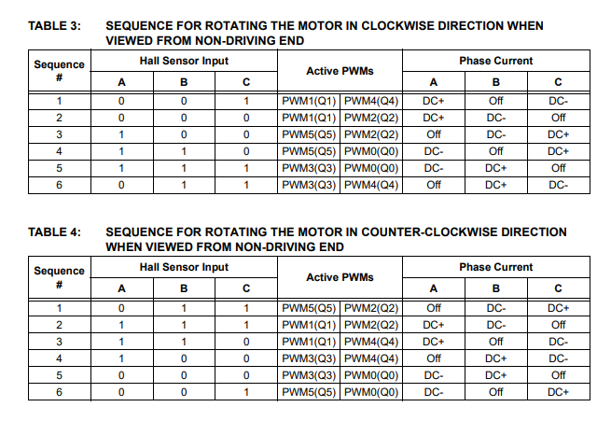

1. Control Algorithms
   1. Sensorless Control of BLDC Motors

Until now we have seen commutation based on the rotor position given by the Hall sensor. BLDC motors can be commutated by monitoring the back EMF signals instead of the Hall sensors. The relationship between the sensors’ output and the BEMF is shown in Figure 15. The sensor signal changes state when the voltage polarity of the BEMF crosses from positive to negative or from negative to positive. In ideal cases, this happens on zero-crossing of back EMF, but practically, there will be a delay due to the winding characteristics. This delay should be compensated by the microcontroller.

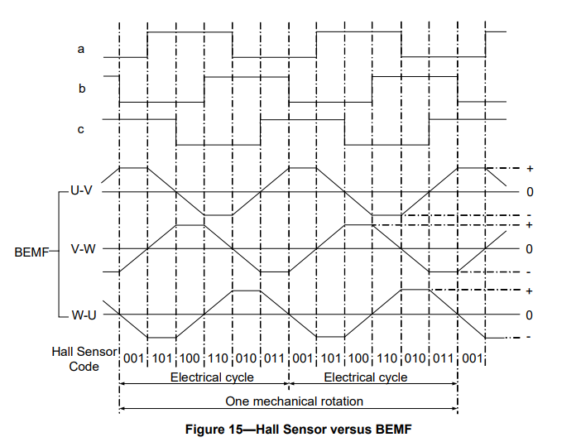

However, as BEMF is proportional to the speed of rotation, this implies that the motor requires a minimum speed for precise feedback. So, under very low speed conditions, such as start-up, additional detectors, like open loop or BEMF amplifiers are required to control the motor. The minimum speed at which back EMF can be sensed is calculated from the back EMF constant of the motor.

Figure 10 shows a block diagram for sensorless control of a BLDC motor.

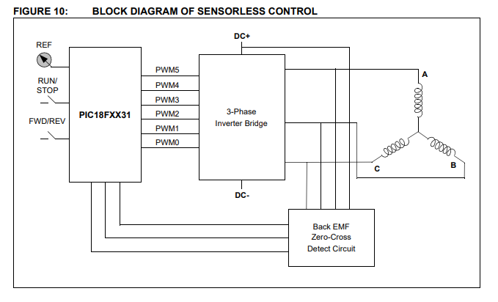

* 1. Open-loop and Close loop
     1. Closed-loop control

In a closed-loop control system, the output of the system is measured and fed back to the input, where it is compared to the desired output. The controller then adjusts the input to the system to minimize the error between the desired and actual output. This feedback process allows the system to achieve and maintain its desired output, even in the presence of disturbances.

Closed-loop control is the most common type of control system used for BLDC motors. It offers a number of advantages over open-loop control, including:

**Accuracy**: Closed-loop control systems can achieve a higher degree of accuracy than open-loop control systems, as the feedback loop allows the system to compensate for errors.

**Robustness**: Closed-loop control systems are more robust to disturbances than open-loop control systems, as the feedback loop allows the system to adjust its output to maintain its desired performance.

**Efficiency**: Closed-loop control systems can be more efficient than open-loop control systems, as they can optimize the system's operation to minimize energy consumption.

3.2.2 Examples of close and open-loop control [([info])](https://control.com/technical-articles/in-introduction-to-types-of-closed-loop-motor-control/)

**Closed-loop control:**

Current Limit Control:Current limit control is used to limit the current to the converter and motor for quick variable operations. The feedback in this is the motor current and is fed to a threshold logic circuit. The threshold logic circuit only monitors until the motor current is below the maximum permissible current. Once that is breached, the feedback loop activates and forces the current to normal, and, once it has been achieved, the feedback loop becomes inactive.

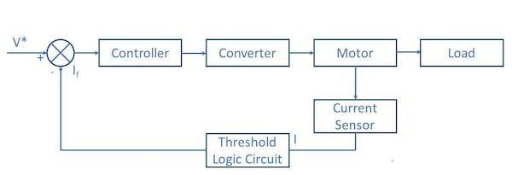

Speed control: A closed-loop speed control system has multiple feedback loops for motor control. The inner loop is a simple current limit closed control loop. The inner loop also keeps the torque output below a safe limit. The outer loop helps to control the speed of the motor. The schematic for closed-loop speed control is given below.

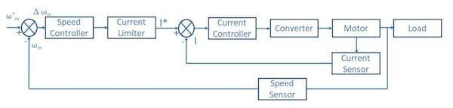

The refence speed of the system is W*m, and the actual speed of the motor, measured by speed sensor, is Wm. This produces a positive error of ΔW*m. This speed error passes through the speed controller and current limiter. For even small errors, the current limiter

is overloaded and sets the reference current for the inner closed control loop. This accelerates the motor and the motor speed increases. This decreases the speed error ΔW*m.

Once the motor speed equals the reference speed and later accumulates a negative speed error, the current limiter saturates and starts to act as brakes to the motor. This is how a simple, closed-loop speed control works.

Position control: A closed-loop position control system uses a position sensor to measure the motor's shaft position and feed it back to the controller. The controller then adjusts the motor's voltage to move the shaft to the desired position.

Torque control: Closed-loop torque control is most common in electric automobiles and locomotives. The desired torque for the motor is determined by the accelerator as reference torque (T*) in Figure 5 below.

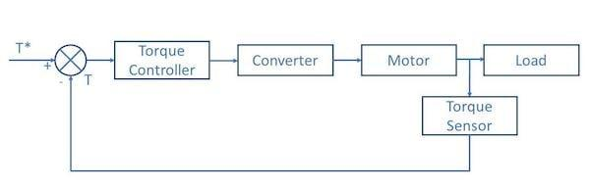

The output of the motor is measured using a torque sensor. If the measured torque is less than the desired torque, the torque controller pushes to provide more torque. It goes on until it

reaches the desired torque. In electric cars and automobiles, this takes just split seconds. The feedback loop is activated multiple times in a small timeframe.

3.2.3 Open-Loop Control

In an open-loop control system, the output of the system is not measured or fed back to the input. The controller simply applies a predetermined input to the system, and the system's output is determined by its dynamics and the input.

Open-loop control is simpler to implement than closed-loop control, but it is also less accurate and robust. Open-loop control systems are typically used in applications where the system's dynamics are well-known and the environment is relatively stable.

**Open-loop control examples:**

Fan control: An open-loop fan control system simply applies a constant voltage to the fan motor. The fan will then spin at a speed that is determined by the voltage and the fan's load.

Pump control: An open-loop pump control system simply applies a constant voltage to the pump motor. The pump will then pump water at a rate that is determined by the voltage and the pump's load.

Conveyor belt control: An open-loop conveyor belt control system simply applies a constant voltage to the conveyor belt motor. The conveyor belt will then move at a speed that is determined by the voltage and the conveyor belt's load.

* 1. Control Techniques

Motor control techniques are primarily divided into two categories: scalar and vector control. These techniques are used to control the operation and performance of motors, particularly in variable-frequency drives (VFDs) for three-phase induction motors.

**Scalar Control**

Scalar control, also known as Volts/Hz control, is a simpler and more basic method of controlling motors. It involves controlling the magnitude of voltage and frequency, but not the phase between them. The general principle is to deliver more voltage as the desired speed increases, maintaining a constant Volts/Hz ratio. This method is well-understood and still functions effectively with the pulsing output provided by a VFD. However, it does not consider the instantaneous position of the rotor, which can lead to performance limitations, particularly in dynamic conditions control.com.

**Vector Control**

Vector control is a more complex method that controls both the magnitude and phase of the voltage and current. This allows the motor to be controlled like a separately excited DC motor, providing superior performance, particularly in dynamic conditions. Vector control involves the use of mathematical transformations to convert the three-phase system into a two-coordinate (d, q) system, with one component defining the magnetic flux of the motor, and the other the torque. This allows the currents to be controlled independently, providing better control of the motor's speed and torque control.com, en.wikipedia.org.

There are several sub-categories of vector control, including:

Direct Vector Control: This method directly calculates the required voltage vector without the need for a rotating reference frame, and without the need for feedback about the rotor's position.

Indirect Vector Control: This method requires information about the rotor's position, which is often obtained through a shaft encoder. It uses a rotating reference frame aligned with the rotor flux for the calculations.

Sensorless Vector Control: This method doesn't require feedback about the rotor's position. Instead, it estimates the rotor's position and speed from the stator voltages and currents.

Field-Oriented Control (FOC): Also known as rotor flux-oriented control or simply vector control, FOC aligns the stator current vector with the rotor flux vector in a rotating reference frame. This allows the torque-producing component of current to be controlled independently of the flux-producing component, providing high performance and fast response times control.com, en.wikipedia.org.

In summary, while scalar control is simpler and less expensive to implement, it offers less precision and control over the motor's performance. Vector control, while more complex, offers superior performance, particularly in dynamic conditions. The choice between scalar and vector control will depend on the specific requirements of the application.